Mealworm Investigation Procedures

Data you will collect:
- Mass of mealworms—Starting and Ending
- Mass of food—Starting and Ending
- Mass of combined mealworms and food—Starting and Ending

Procedures:
Step 1: Get a container for growing your mealworms. Make sure the container has holes in the lid for ventilation so your mealworms have air. Measure the mass of the container without the lid. Record this mass at the very bottom of your worksheet, then set the container aside.

Step 2: If your mealworms are already in their food and container, you will need to separate the mealworms from the food to get a starting mass for the worms only and the food only. Using tweezers, separate all the worms from the food. Set worms in a separate container. If your worms come already separated from food, skip this step.

Step 3: Place an empty paper cup onto the digital balance and “zero” out the scale. Then pour all food contents into the empty cup. You should try to have around 30 grams of food available to your worms (about ½ cup of food). Record the Start Mass for your food only.

Step 4: Place another empty cup onto the digital balance and “zero” out the scale. Then pour all mealworms into this container. You should have at least 6-10 gram of mealworms. Record the Start Mass of the mealworms only on your worksheet.

Step 5: Add the mass of the food and the mass of the mealworms and place this total in Line 3 Start mass for your combined food and mealworms.

Step 6: Pour all the food and mealworms into your permanent container. Make sure that all the food goes into the container. Take a final mass reading of everything combined (without the lid). Record this mass in Line 4 of your table. Then place the lid onto your container and place the mealworms in a designated place.

Check: Your can double-check the accuracy of your measurements by adding Line 3 mass to the mass of the empty container. This should match the Line 4 mass.

Final Mass: After 2-3 days you will measure the mass of the food and the mass of the
mealworms again, following the same procedures above. Place these final mass measurements in your data table.

What Makes Up Our Foods?

You have probably seen nutrition labels that are found on most food packages. Scientists use tests to find out what makes up the foods we eat, and then food companies use labels so that people who buy their products also know what makes up these foods.
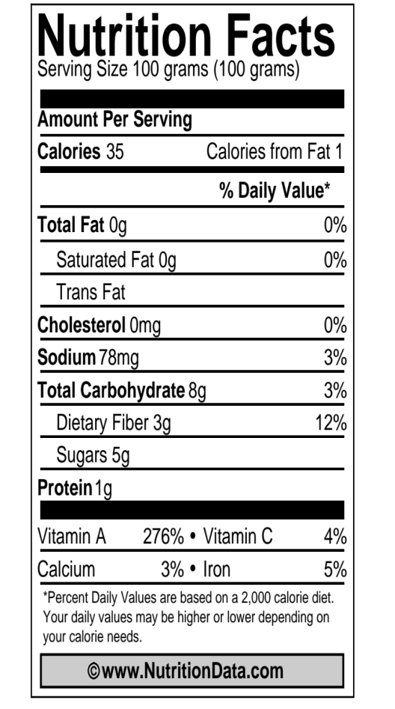
Today you will work with your group to explore different food labels and think about why our bodies need the nutrients found in food. First, you need to understand how to read the food labels. Look at the food label to the right. This food label is for carrots. Just by looking at this label, what are some things that make up the carrots that we eat?

Now, take a closer look at the label and think about what each of the things provide our bodies.

What are calories?

The label shows that there are 35 calories in every 100 grams of carrots. But what are calories?

Scientist use “calories” to measure how much chemical energy is found in foods. Foods that have calories are good sources of chemical energy for our
bodies. Things that do not have calories cannot provide
chemical energy for our bodies. Food is our only source of
chemical energy.

What are the basic building blocks of food?

Some things found in foods are organic materials that have chemical energy but some things do not. The organic materials in food include carbohydrates, proteins, and fats.
- Carbohydrates include sugars, starches, and fiber. Carbohydrates are found in most foods, especially breads, pastas, sweets, and vegetables, like potatoes.
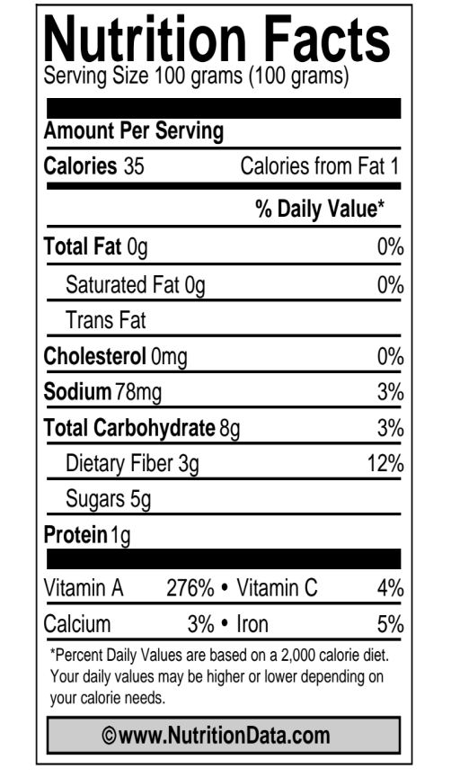
- Proteins are found in many foods, especially meats, beans, and dairy products.
- Fats are found in many foods, such as butter that we use for cooking and baking.
These three things have calories, which mean they have a lot of chemical energy for our bodies. The three things are also made mostly of carbon, hydrogen, and oxygen atoms and have high-energy bonds. They are organic materials.

What about vitamins and minerals?
Look at the label carefully. Can you find the vitamins and minerals that are found in carrots? What are they?
Vitamins and minerals like calcium and iron are micronutrients. They are important for our bodies to stay healthy, but they are present in foods in very small quantities. Their total weight in a 100 g serving of food is almost always less than 1 g.

What is missing from the labels?
Suppose we add up the materials listed on the carrot label:
Total fat: 0 g
Total carbohydrates: 8 g
Total protein: 1 g
Total vitamins and minerals: less than 1 g
So that’s about 10 g of organic materials and minerals, but the serving size is 100 g. What is the other 90 g?

The answer is that nutrition labels do not include water, so the other 90 g of a carrot is water: Carrots are about 90% water!

Now you will work with a group to look at different nutrition labels. In your group, you will need to decide which foods have chemical energy for our bodies and which do not.

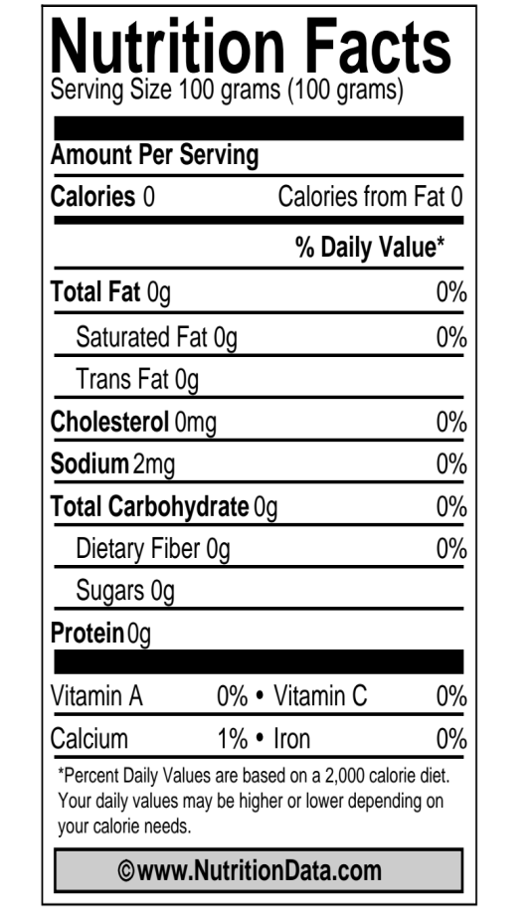
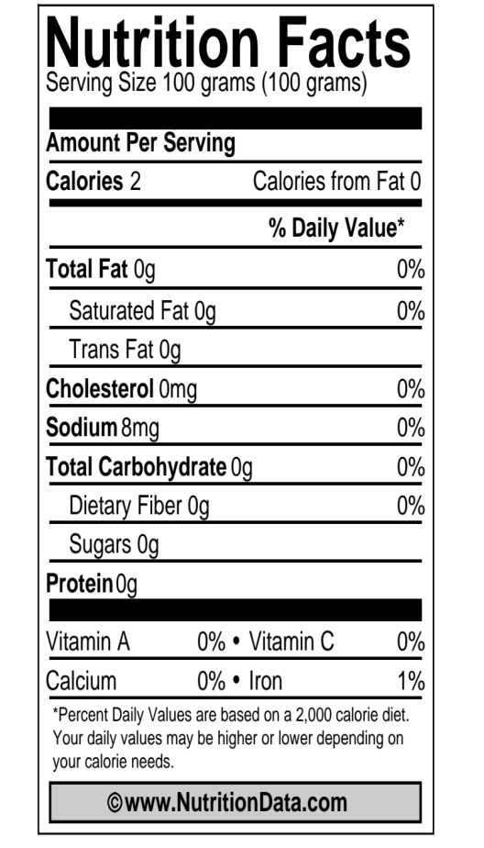
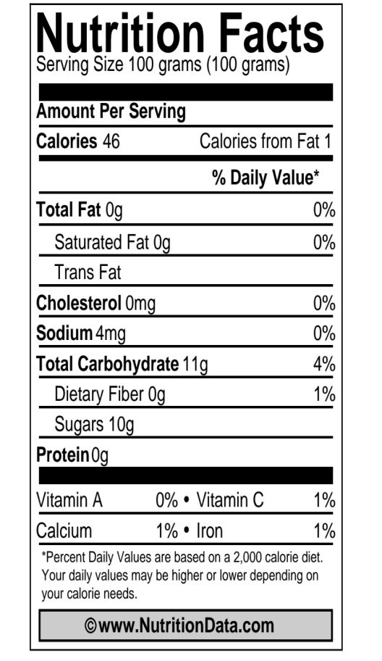
WATER
DIET SODA
APPLE JUICE

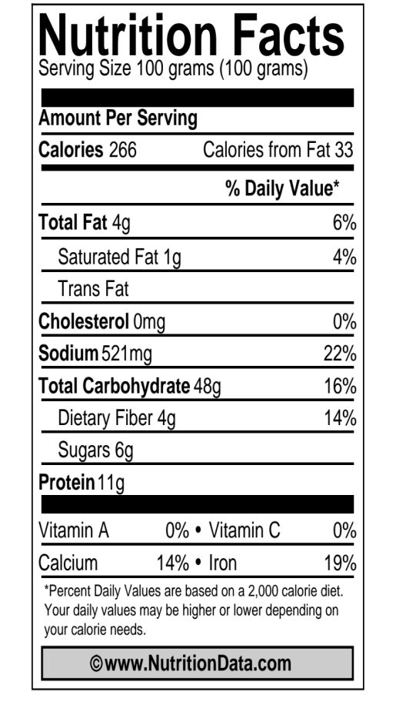
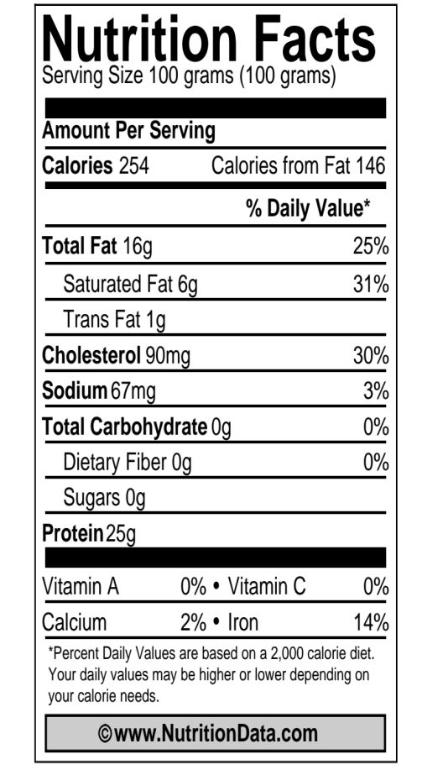
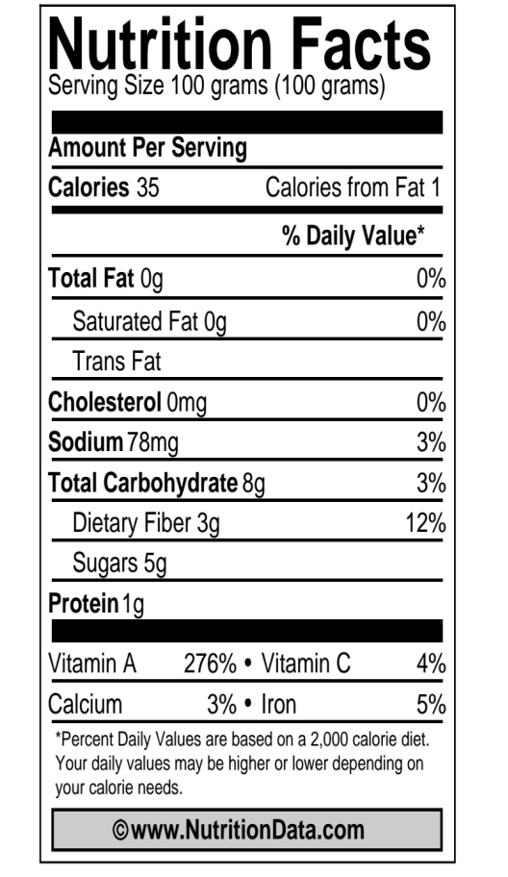
WHEAT BREAD
BEEF (80/20)
CARROTS

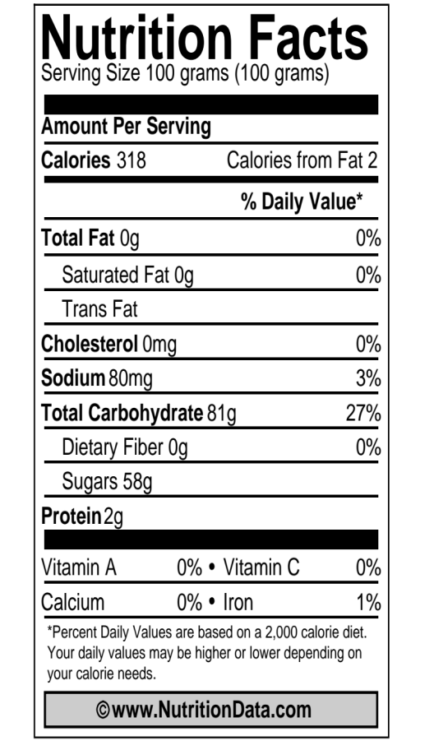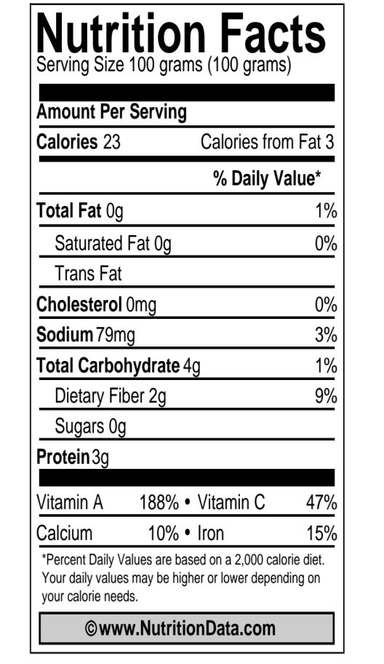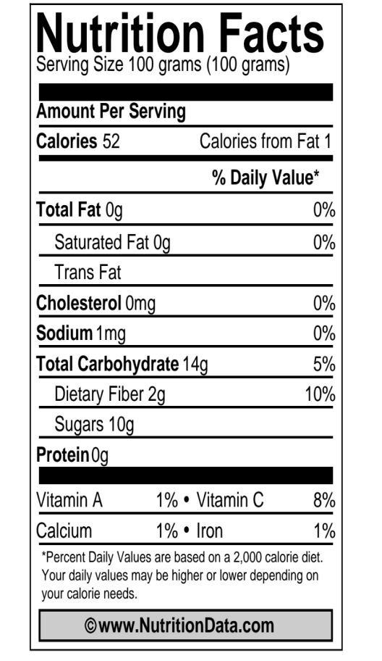§
MARSHMALLOWS
SPINACH (FRESH
)
APPLES (RAW)

Comparing Food Molecules
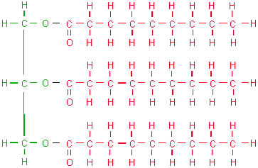

LIPID/FAT

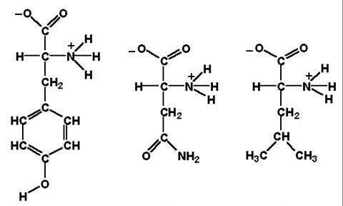

AMINO ACIDS
IN PROTEINS

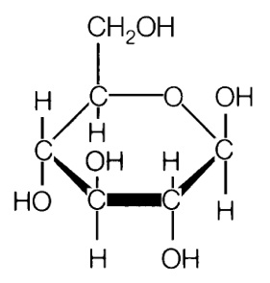

GLUCOSE

STARCH
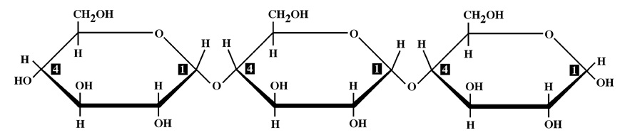

Building Polymers from Monomers
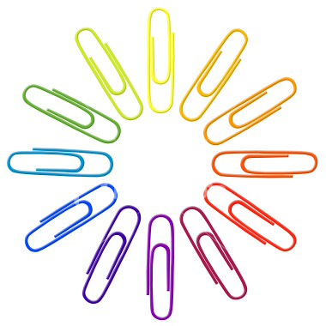
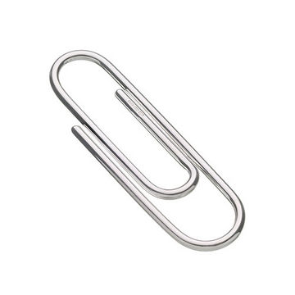
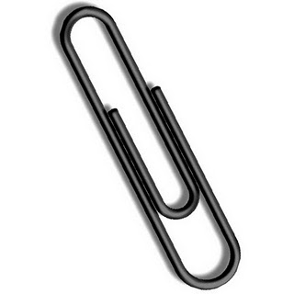
Glucose Amino Acids
(Silver) (Colorful)
(Black for Cellulose)

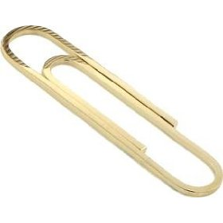
Glycerol Fatty Acids
(Large Gold) (Small Gold)

Use this information to build: 1) STARCH and FIBER molecules
2) LIPID molecules
3) PROTEIN molecules

Step 1: Build a STARCH molecule by linking together 6 small, silver paperclips. Each silver paperclip represents a glucose molecule, so a starch molecule is a chain of glucose molecules. Build two starch molecules total. The extra silver paperclips represent glucose (sugar) we eat.
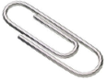

Step 2: Build a LIPID (or fat) molecule by linking three fatty acids to one large gold paperclip, which represents a glycerol molecule. You will make two total fat molecules.

Step 3: Build PROTEIN molecules by making chains of different amino acids. Choose 5 different colors (red, yellow, blue, green, purple, etc) and link the colorful paperclips together. Each color represents a unique amino acid and when combined in different ways you get different protein molecules. Make up to three protein molecules using your 15 colorful paperclips.
Step 4: One type of carbohydrate is cellulose (the main component of fiber on food labels). Cellulose is actually made from glucose, but the glucose is linked differently from glucose in a starch molecule. Build a FIBER molecule by linking together 4 black paperclips. You will need to build two fiber molecules with your 8 black paperclips.

Digesting Food Molecules
Starch Monomers Protein Monomers
(Silver) (Colorful)

Fat Monomers Fiber Monomers
(Gold) (Black)

Use this information to digest: 1) STARCH and FIBER polymers
2) LIPID polymers
3) PROTEIN polymers

Step 1: Digest a STARCH molecule by breaking the starch molecule into individual glucose molecules.

Step 2: Digest a FAT molecule by separating the three fatty acids from the glycerol molecule.

Step 3: Digest PROTEIN molecules by breaking the protein into individual amino acids.

Step 4: People cannot digest cellulose or fiber molecules, but cattle can digest some cellulose. Digest cellulose molecules by breaking the chain of glucose molecules into individual glucose molecules
What Is Cellular Respiration?

People eat food and breathe in air, but are these two things connected? What do you think?

What do we get from air?
You may think we breathe because we need oxygen to live. That is only partly right. With every breath, your lungs fill up with air. Most of that air you breathe right back out again. But you don’t breathe out all of the oxygen you took in. The inside of your lungs is like a sponge. Lungs have tiny spaces for the air to go into, and each space is surrounded by tiny blood vessels. Some of the oxygen goes into the blood vessels. The blood takes oxygen to the cells.

What do we get from food?
You’ve already learned that we get organic matter from the foods we eat. These are carbohydrates, proteins, and fats. This organic matter is digested down to monomers and taken to cells by the blood. Sometimes cells rebuild the monomers back into polymers in order to grow. But most monomers are used by cells in a different way. They are “reacted” with oxygen. What happens when organic matter is reacted with oxygen? Do you have any ideas?

What happens in the cell?
Every cell in your body needs energy, but how does it get energy? At first the energy is stored in food molecules as chemical energy. The food molecules have carbon-carbon and carbon-hydrogen bonds. The cell can change this chemical energy into other forms of energy, such as kinetic energy, more chemical energy, or heat. The cell does this by reacting food molecules with oxygen and changing the organic food matter into waste products it doesn’t need: carbon dioxide and water. How can it get rid of the waste products? Give them back to the blood!

Macroscopic: 1 Meter (10⁰)  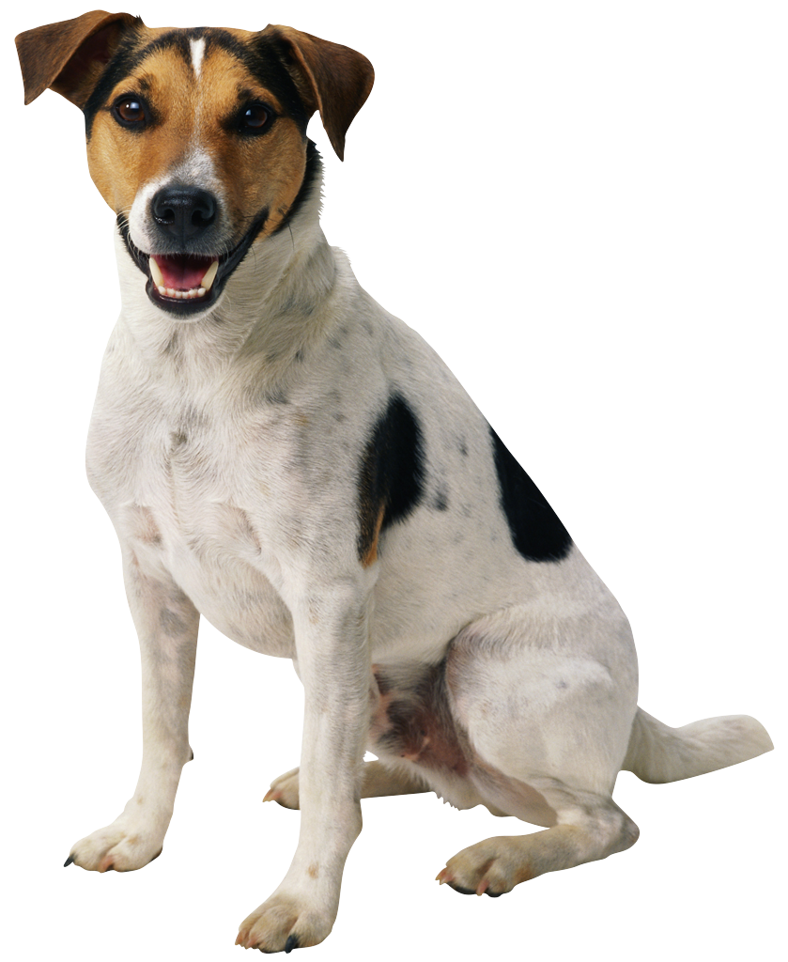 |  | Microscopic: 2 Micrometers (10⁻⁶)
 |  | 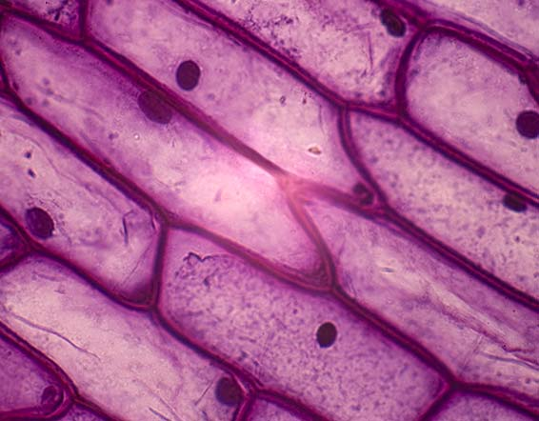
Atomic-Molecular: 100-500 Picometers (10⁻¹⁰)
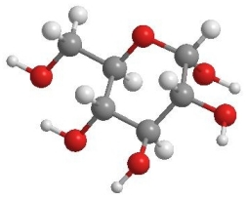

MATTER: Glucose(C₆H₁₂O₆) + 6Oxygen(O₂) → 6Carbon Dioxide(CO₂) + 6Water (H₂O)

ENERGY: chemical energy → kinetic energy + heat

Evidence of Cellular Respiration

We Breathe Out CO₂ and H₂O: As cells work, they give off carbon dioxide and water that they do not need. Carbon dioxide and water are inorganic molecules that do not have chemical energy. These molecules leave the cells and go back into the blood vessels. Eventually the H₂O and CO₂ leave our bodies. Carbon dioxide leaves when we breathe out. Water leaves when we breathe, sweat, or even as urine. What ways could you measure that animals give off H₂O and CO₂ when they breathe all from cellular respiration?
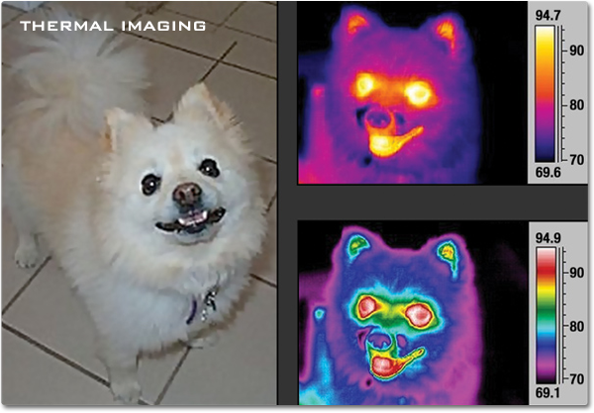
We Give Off Heat: Just like burning fuels or food changes chemical energy to heat, animal cells do a similar thing during cellular respiration. In fact, the body gives off the same amount of heat through cellular respiration that would have been given off if the food was burned. A scientist name Max Rubner proved this to be true over 100 years ago. He found that burning dog food released the same amount of energy as was released if the dog ate and metabolized the food! This also explains why our bodies stay a warm 98.6° whether it’s a warm or cold day outside!

Our “Energy Level” Changes With Food:
If animals do not get enough food and chemical energy they get tired. But when animals eat, they feel “energized”. That’s why athletes eat certain food before a big race. Our bodies react the food with oxygen, changing the chemical energy in food into motion energy we use to move around and be active.

Modeling Cellular Respiration Instructions

In your groups, you will use molecular model kits to model the process of cellular respiration. You will build the materials that go into the cells, and then use the models to show how those materials change inside cells. The equation for cellular respiration is:

MATTER: Glucose(C₆H₁₂O₆) + 6Oxygen(O₂) → 6Carbon Dioxide(CO₂) + 6Water (H₂O)

ENERGY: chemical energy → kinetic energy + heat

This means that a glucose molecule is reacted with 6 oxygen molecules to form 6 carbon dioxide molecules and 6 water molecules. In order to model cellular respiration, you will first need to build your glucose and oxygen molecules.
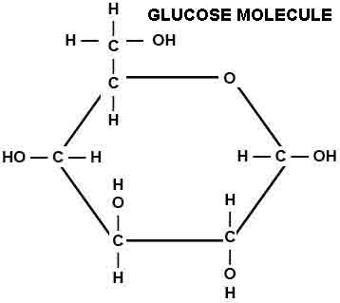
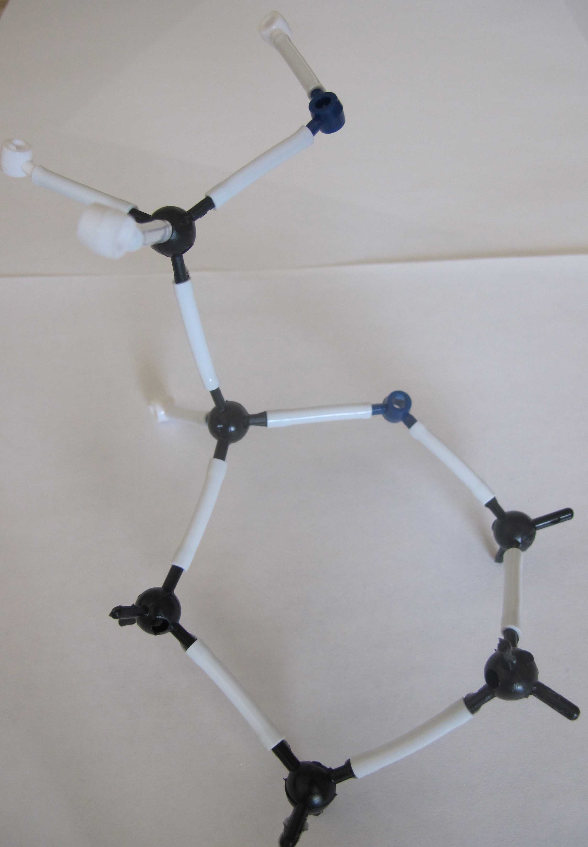
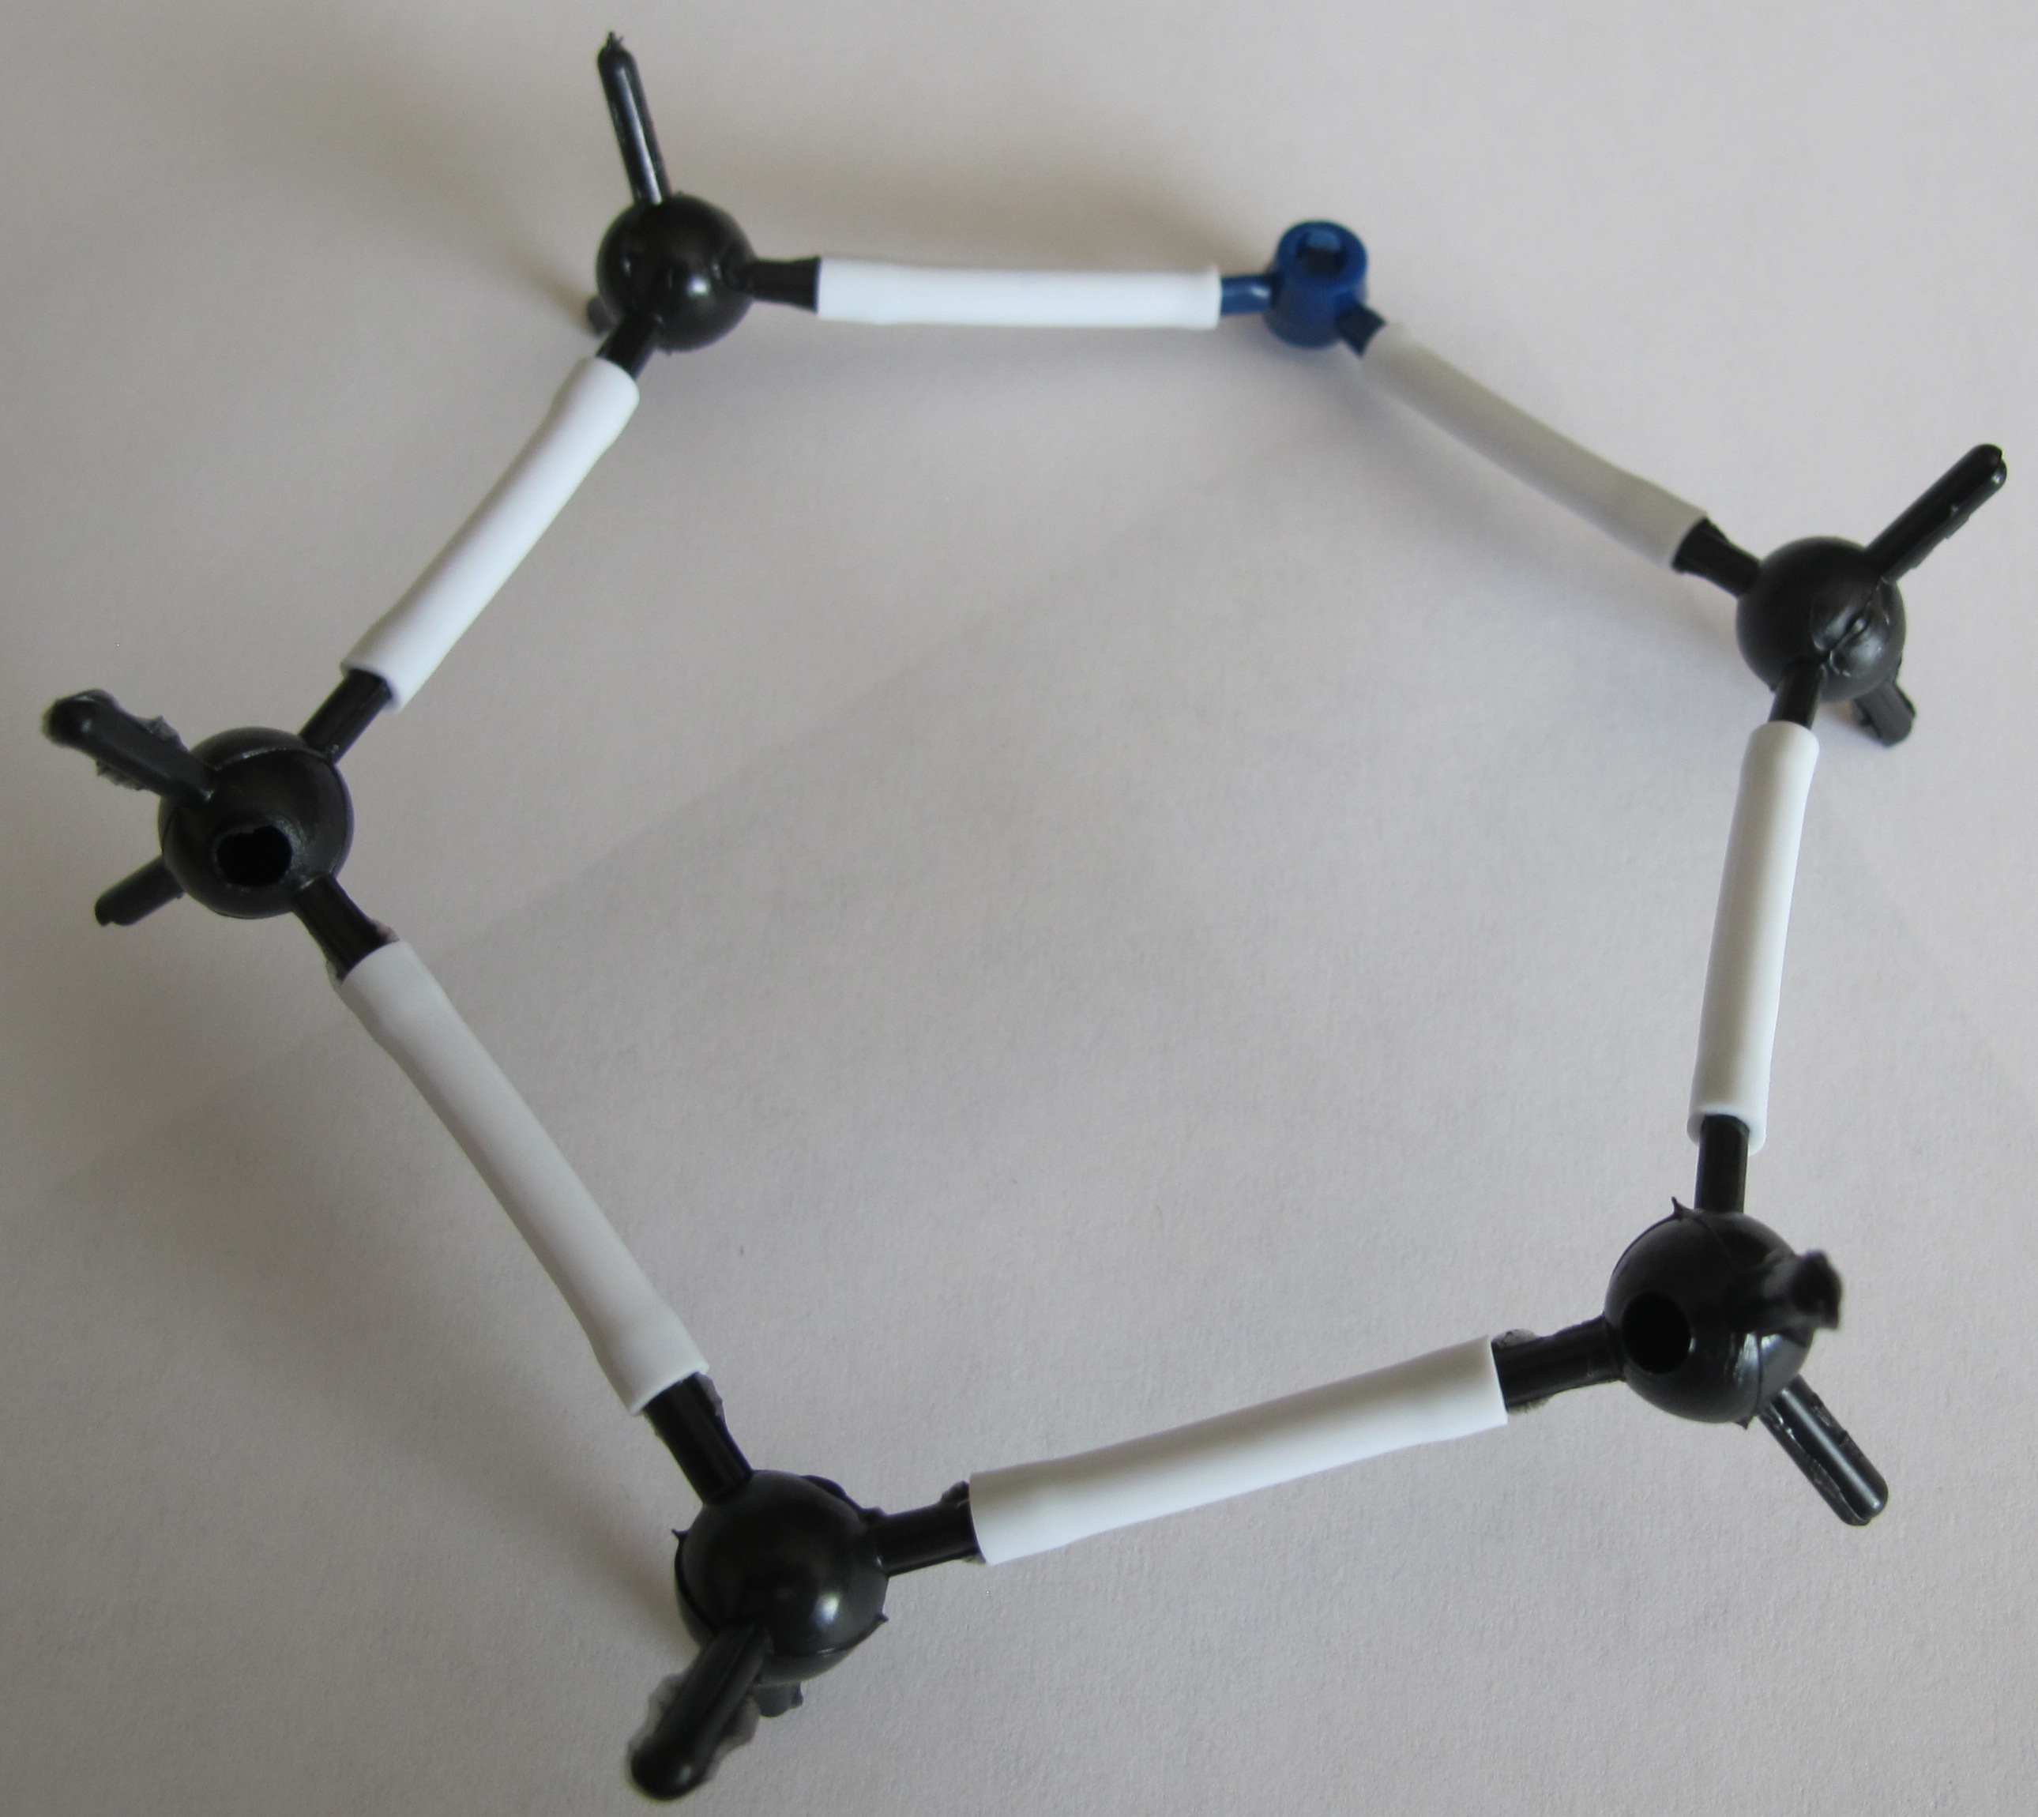
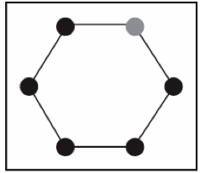
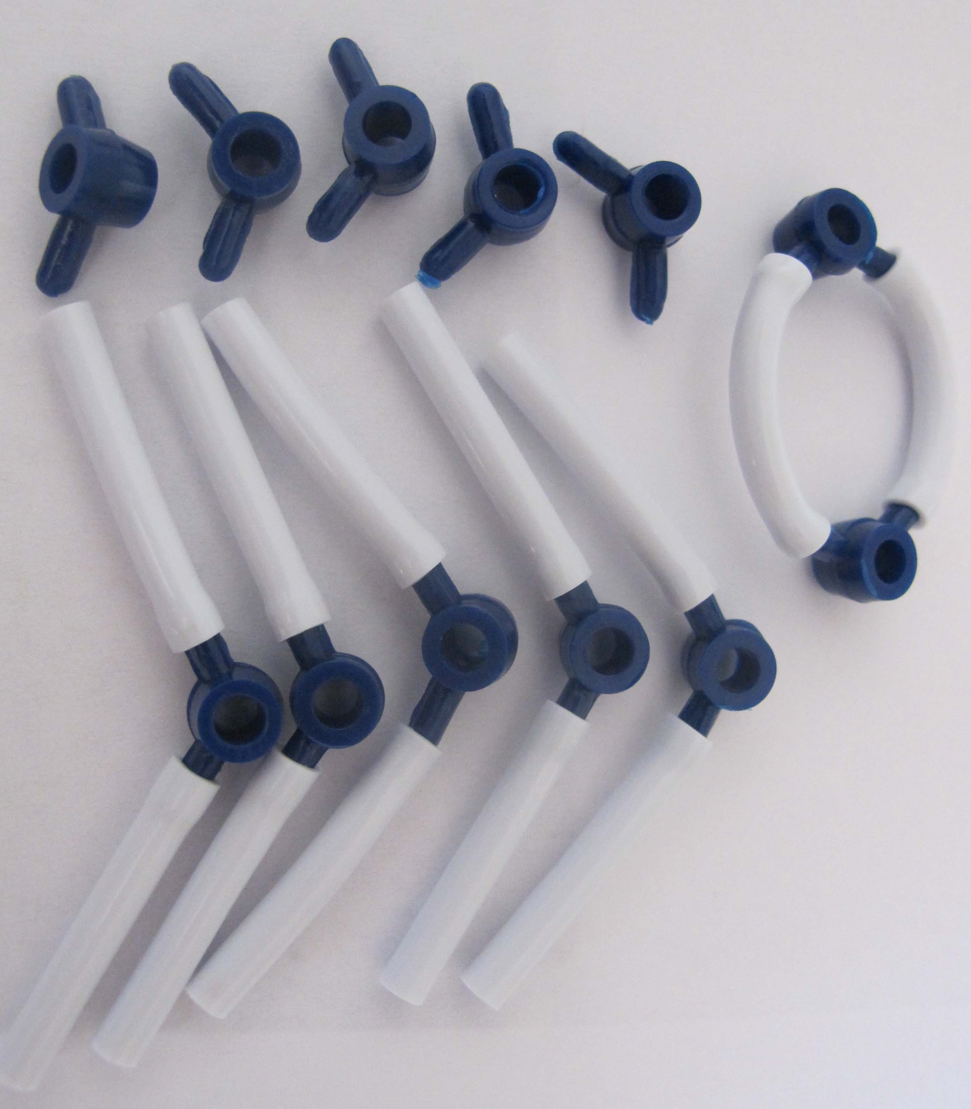
Step 1: Make Your Oxygen Molecules: Assign one person in your group to start working on the oxygen molecules. This person will need to make 6 oxygen molecules. Oxygen is 2 oxygen atoms connected using a double bond.

Step 2: Make Your Glucose Molecule: The rest of the group should work on the glucose molecule. First make the “glucose ring”, which is made of 5 carbon atoms and 1 oxygen atom connected to form a circular shape.

Next you will add the CH₂OH group. You will work with the carbon that is to the left of the oxygen in your ring. On this carbon, connect a second carbon. On the second carbon, attach 2 hydrogen and 1 oxygen atom. Attach another hydrogen to the oxygen. Then attach 1 hydrogen to the carbon that is on the ring.
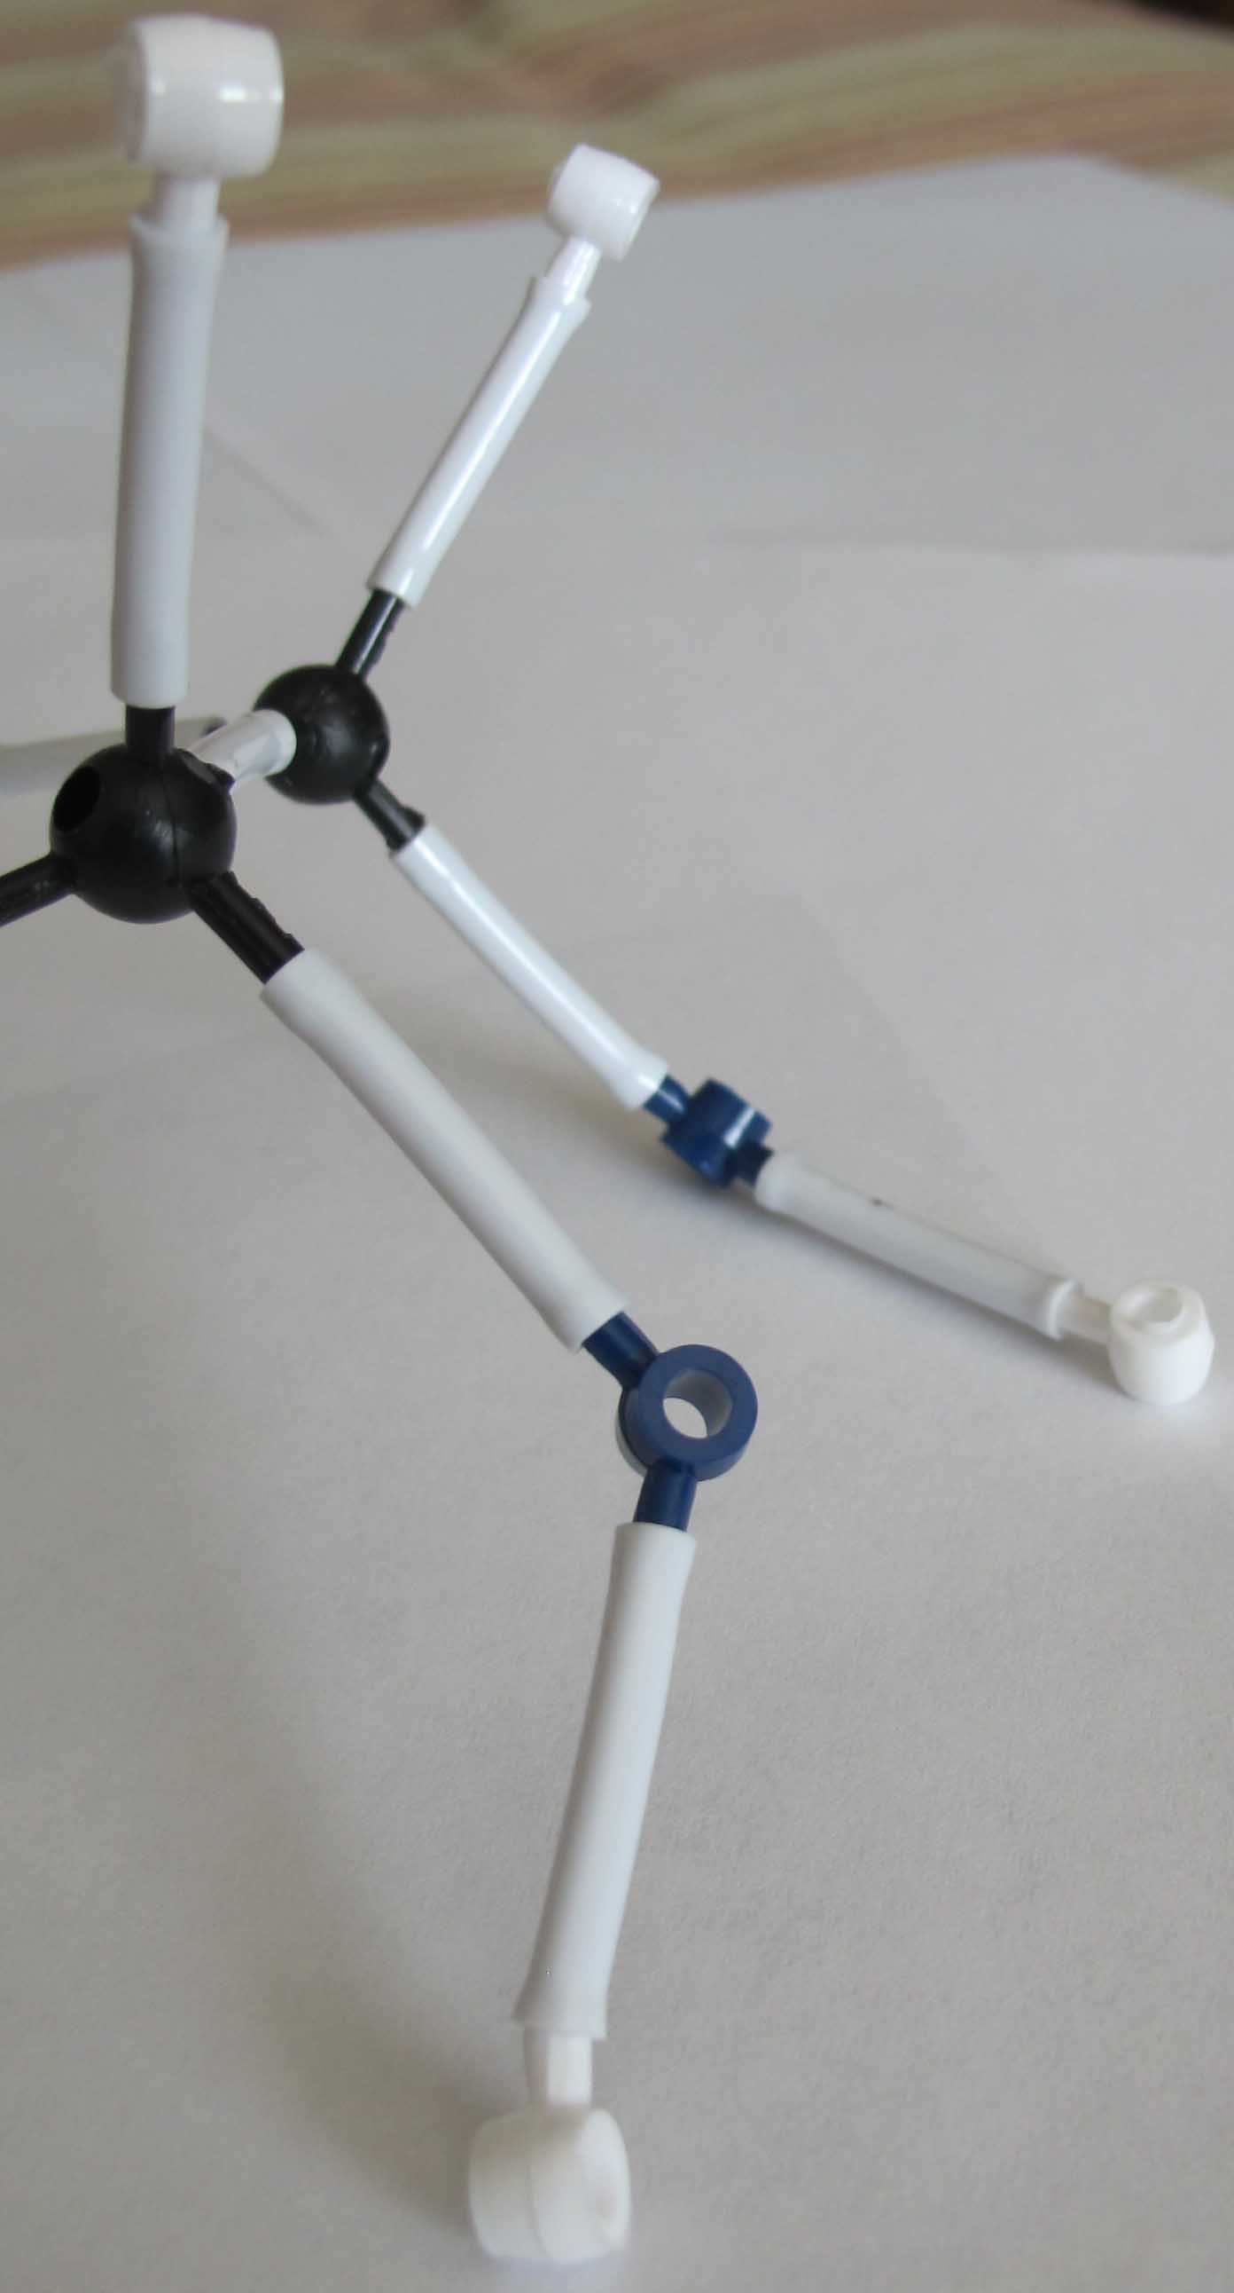
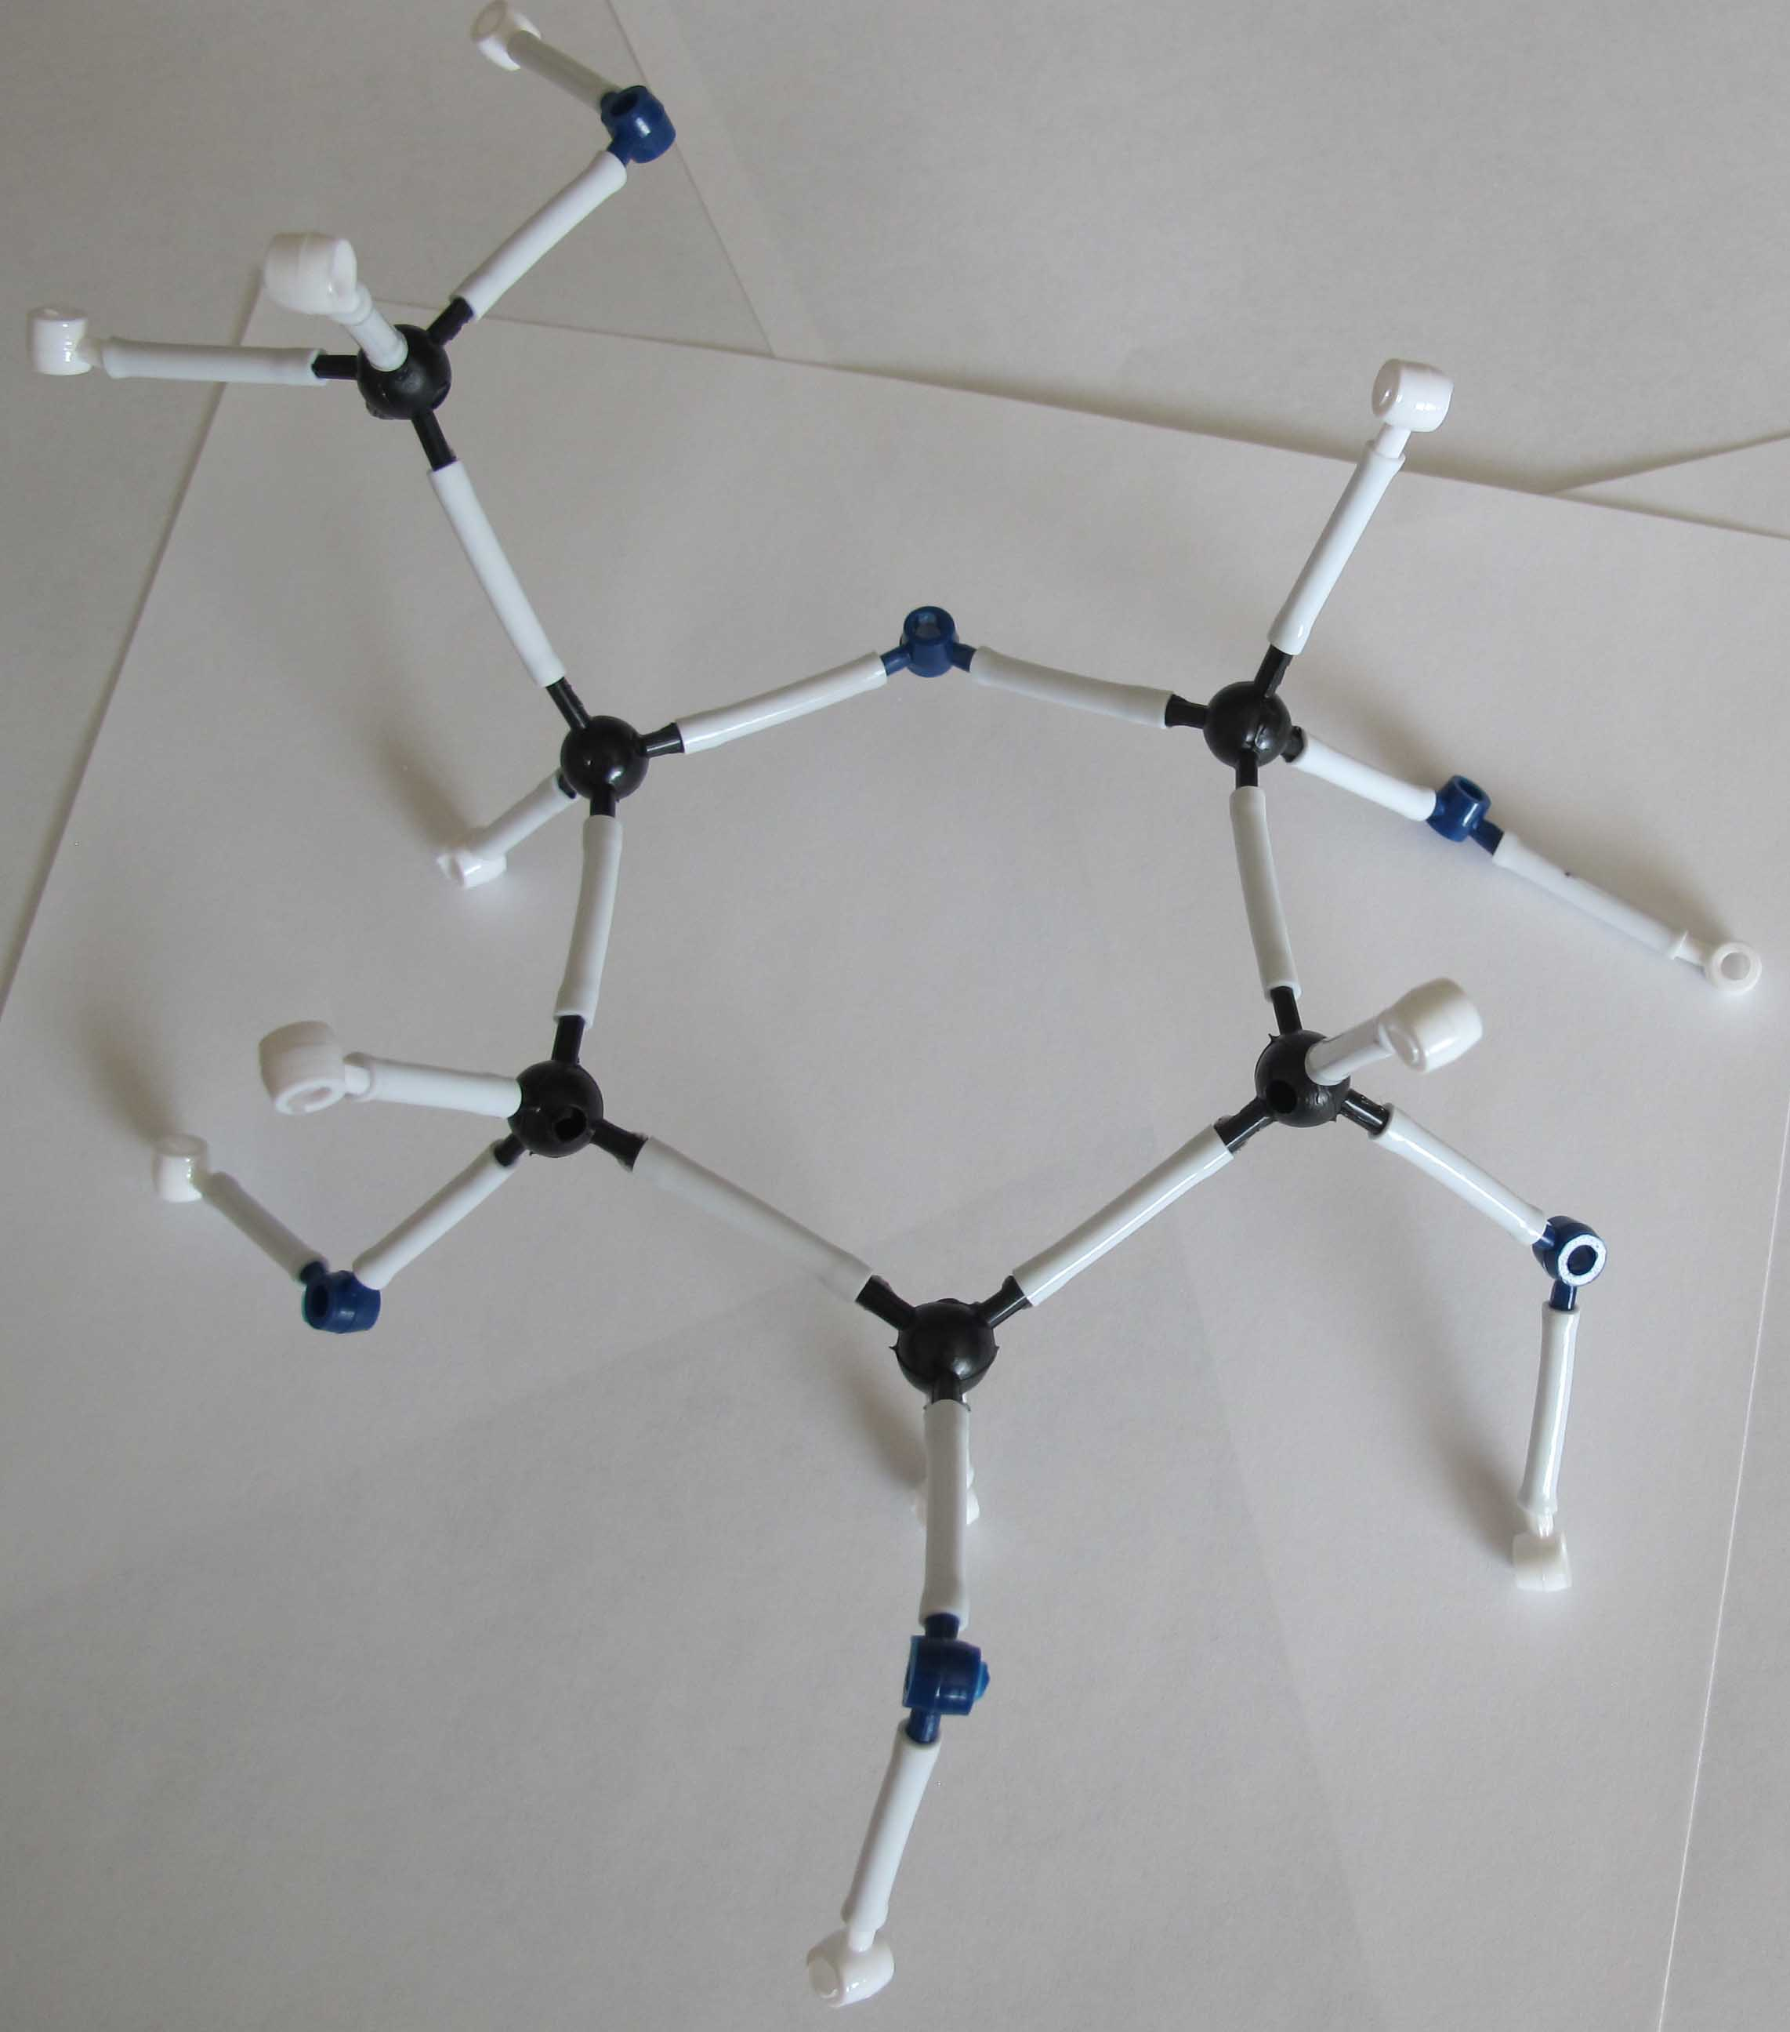
Move to the other four carbons on the ring. Attach 1 oxygen and 1 hydrogen to these carbons. Then attach another hydrogen to each oxygen. Make sure it looks similar to the image on the right.

Step 3: Answer Questions About Your Reactants: Look at your glucose and oxygen molecules. Using your worksheet, answer the questions about these
two molecules. What atoms do these molecules have, and do they have chemical energy?
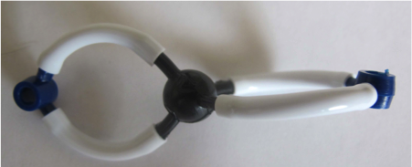
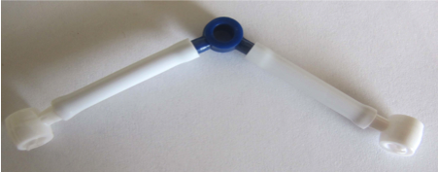
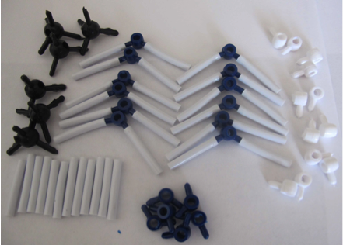
Step 4: Cellular Respiration Happens: In cell respiration, cells break down glucose and oxygen and rearrange the atoms into CO₂ and H₂O. Take apart the glucose molecule and remove 1 oxygen atom from all your oxygen molecules. Leave bonds connected to as many oxygen atoms as possible.

Step 5: Build Your Water Molecules: Water contains 1 oxygen atom and 2 hydrogen atoms. Build 6 of these molecules.

Step 6: Build Your Carbon Dioxide Molecules: Carbon dioxide contains 1 carbon atom and 2 oxygen atoms. There are two bonds between the carbon atom and oxygen atoms (called a “double bond”). Build 6 of these molecules.

Now, answer and discuss the questions on your worksheet.

